PART B

Experiment no: - 1

Experiment Name: - DDL statements.

Aim: - To perform practicals using DDL statements for creating tables, managing table structures, and applying constraints in the Cinema Ticket Booking System.

Roll. No: C-60 | Name: Avdhut Madhavi
Class: COMP-C | Batch: C2
Date of Experiment: | Date of Submission:
Grade:

B.1: Read the given question carefully and write a SQL statement and check the output.
(Put the query and its output after each question.)

1. Create MOVIE table
CREATE TABLE MOVIE (
movie_id INT PRIMARY KEY,
title VARCHAR(50) NOT NULL,
genre VARCHAR(20),
language VARCHAR(20),
duration INT,
rating DECIMAL(3,1)
CHECK (rating BETWEEN 0 AND 10)
);
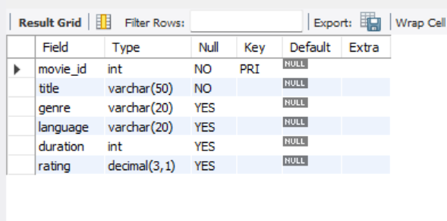

CREATE TABLE THEATRE (
theatre_id NUMBER(5) PRIMARY KEY,
theatre_name VARCHAR2(50) NOT NULL,
city VARCHAR2(30),
phone VARCHAR2(15) UNIQUE);

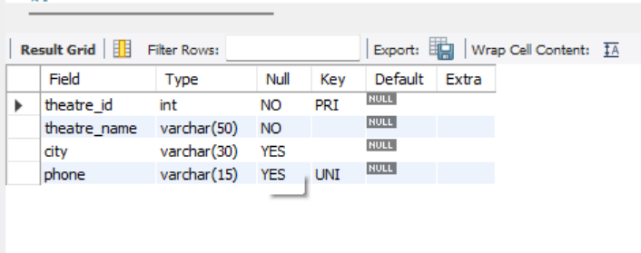

CREATE TABLE SCREEN (
screen_id INT PRIMARY KEY,
screen_name VARCHAR(20) NOT NULL,
capacity INT CHECK (capacity > 0),
theatre_id INT,
FOREIGN KEY (theatre_id)
REFERENCES THEATRE(theatre_id)
);
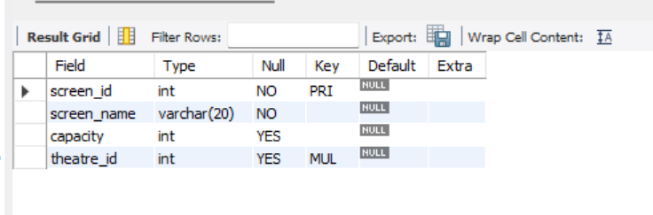

CREATE TABLE SHOWTIME (
show_id INT PRIMARY KEY,
movie_id INT,
screen_id INT,
show_date DATE,
show_time TIME,
ticket_price DECIMAL(8,2)
CHECK (ticket_price > 0),
FOREIGN KEY (movie_id)
REFERENCES MOVIE(movie_id),
FOREIGN KEY (screen_id)
REFERENCES SCREEN(screen_id)
);

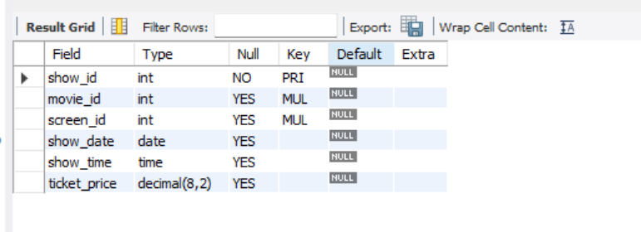

CREATE TABLE SEAT (
seat_id INT PRIMARY KEY,
screen_id INT,
seat_number VARCHAR(10) NOT NULL,
seat_type VARCHAR(15),
UNIQUE (screen_id, seat_number),
FOREIGN KEY (screen_id)
REFERENCES SCREEN(screen_id)
);

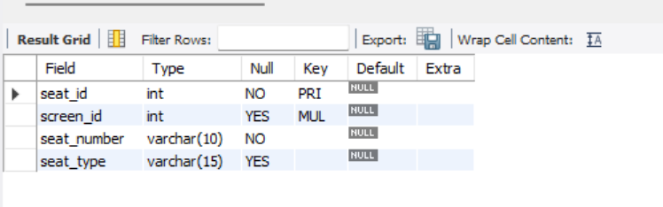

CREATE TABLE CUSTOMER (
customer_id INT PRIMARY KEY,
customer_name VARCHAR(50) NOT NULL,
email VARCHAR(50) UNIQUE,
phone VARCHAR(15),
city VARCHAR(30)
);

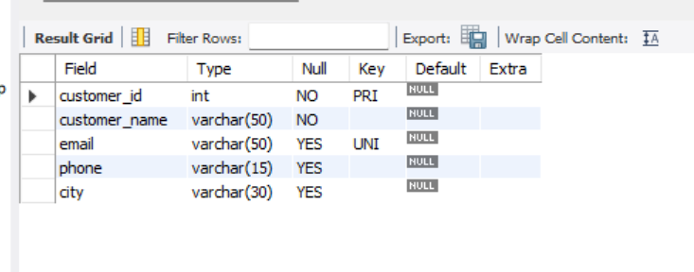

ALTER – Modify table structure

ALTER TABLE MOVIE
ADD remarks VARCHAR(100);
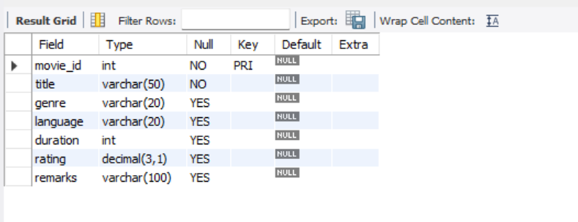

B. Modify a column
Increase the size of the title column from 50 to 100 characters.

ALTER TABLE MOVIE
MODIFY COLUMN title VARCHAR(100);
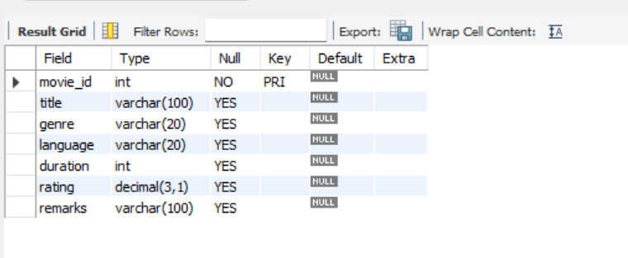

D. Drop a column
Remove the remarks column from Movie_details

ALTER TABLE movie_details
ADD remarks VARCHAR(100);

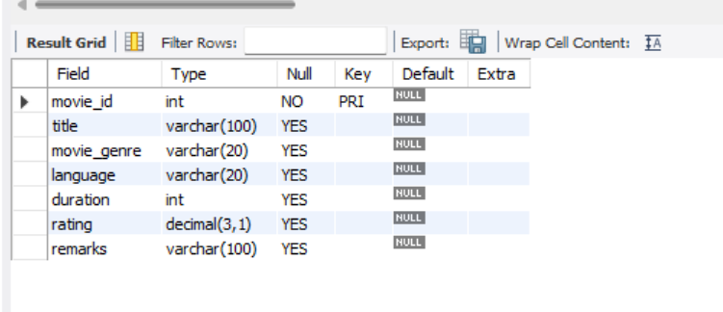

3. RENAME – Rename a table
Rename MOVIE to MOVIE_DETAILS.

RENAME TABLE MOVIE TO MOVIE_DETAILS;

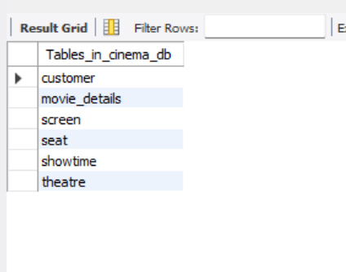
4.DROP – Delete a table
This sql query deletes the table which we created just for this querry.

DROP TABLE TEST_RENAME_NEW;
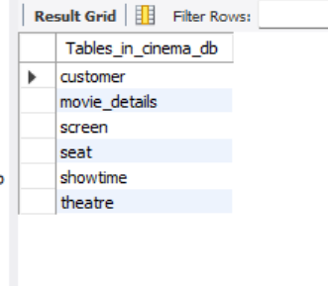

EER Diagram:
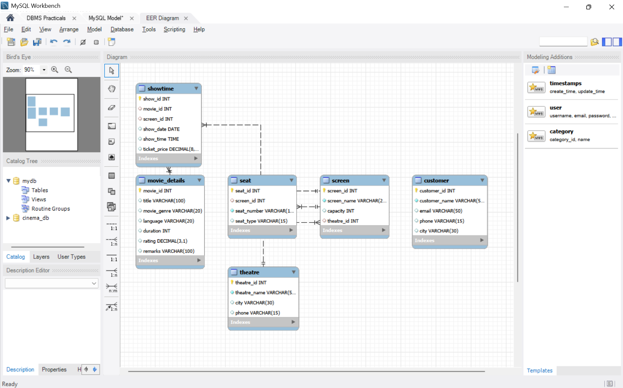
B.2: Write an observation according to the query execution
- The CREATE command was used to create tables in the Cinema Ticket Booking System.
- The ALTER command was used to add, modify, rename, and drop columns.
- The RENAME TABLE command was used to change the name of an existing table.
- The TRUNCATE command was used to delete all records while retaining the table structure.
- The DROP TABLE command was used to delete a table along with its structure and data.
- DDL commands helped us understand how to create and manage database structures.

B.3: Write an answer of the following questions

- What is the difference between the CREATE and ALTER statements?
CREATE | ALTER
1. It is used to create a new table. | 1. It is used to modify an existing table.
2. It defines the table structure. | 2. It changes the table structure.
3. It creates a new database object. | 3. It modifies an existing database object.
Example: CREATE TABLE Student (id NUMBER); | Example: ALTER TABLE Student ADD name VARCHAR2(20);

- Explain the difference between DROP and TRUNCATE statements.
DROP | TRUNCATE
1. It deletes the entire table. | 1. It deletes all records from a table.
2. It removes both data and table structure. | 2. It keeps the table structure.
3. The table cannot be used until it is created again. | 3. New records can be inserted into the table.
Example: DROP TABLE Student; | Example: TRUNCATE TABLE Student;

- What happens when you use the DROP TABLE command?

When we use the DROP TABLE command:
- The entire table is deleted from the database.
- All records stored in the table are removed.
- The table structure, including its columns, is deleted.
- Related constraints and indexes associated with the table are also removed.
- The table must be created again if we want to use it in the future.
EXAMPLE :-
DROP TABLE Student;

